a) eigenvectors, eigenvalues for A

eigenvectors:

|  |  |  |  |
| --- | --- | --- | --- |
| 0.9535 | 0.9535 | 0 | 0 |
| -0.2875 | 0.2875 | 0 | 0 |
| -0.0867 | -0.0867 | 0 | 0 |
| 0.0261 | -0.0261 | -1 | 1 |

eigenvalues: 110.5, -(110.5), 0, 0

b)

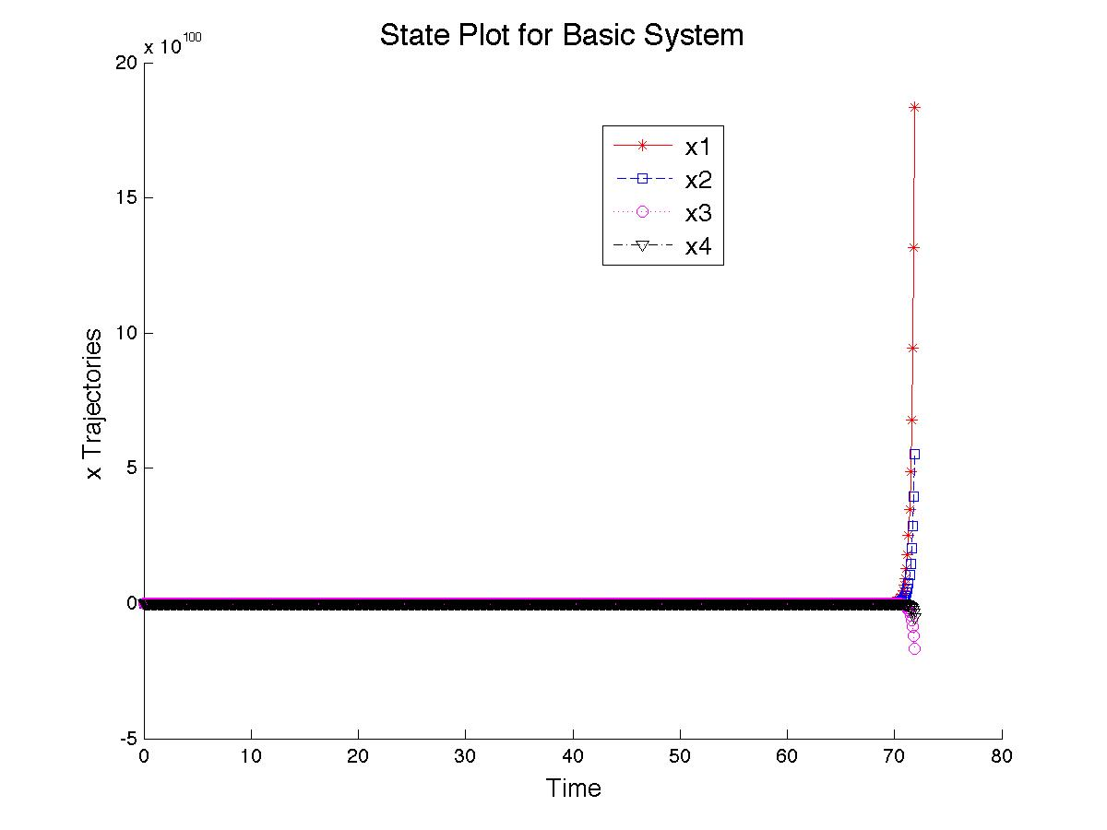

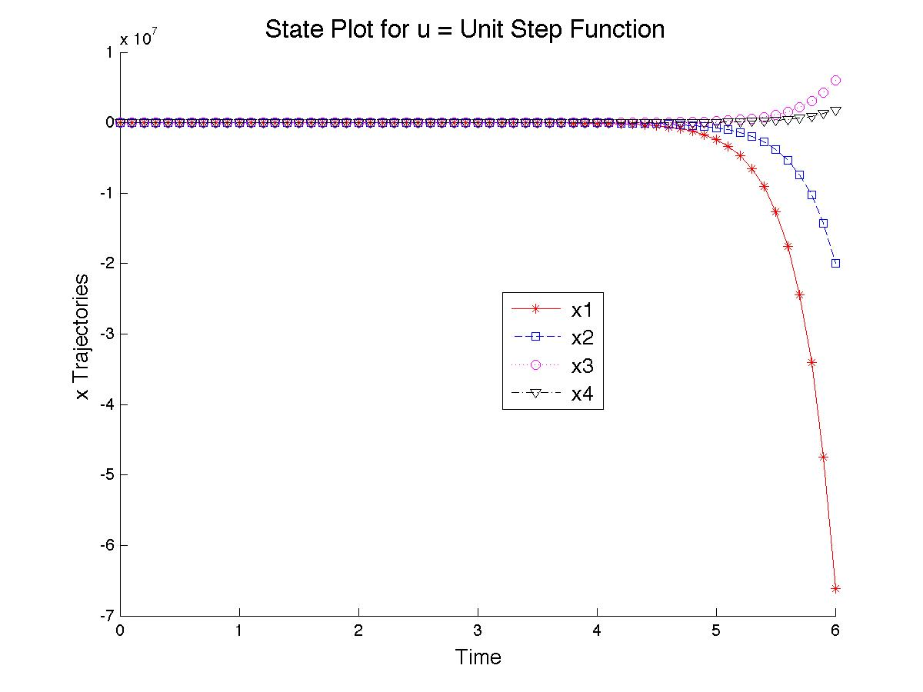

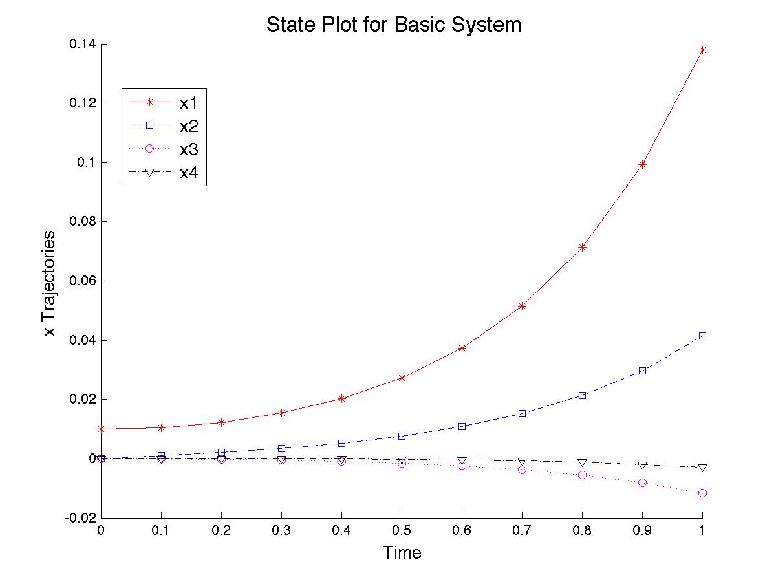

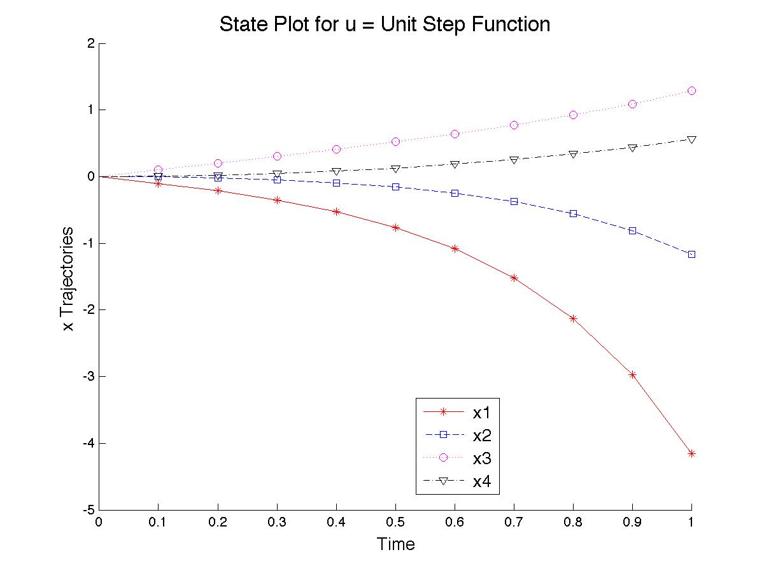

Plots for the homogeneous and driven systems are presented above, for both the “long time” behaviors and the “short time” behaviors. From the “long time” plots (presented first), it can be seen that both systems display unstable behavior (i.e., state values go to ±∞). It is also apparent that the driven system more rapidly diverges from small state values, though the states diverge in the opposite direction as their homogeneous counterparts, as seen more clearly in the “short time” plots, though the relative magnitudes seem to be preserved.

c) See attached.

e)

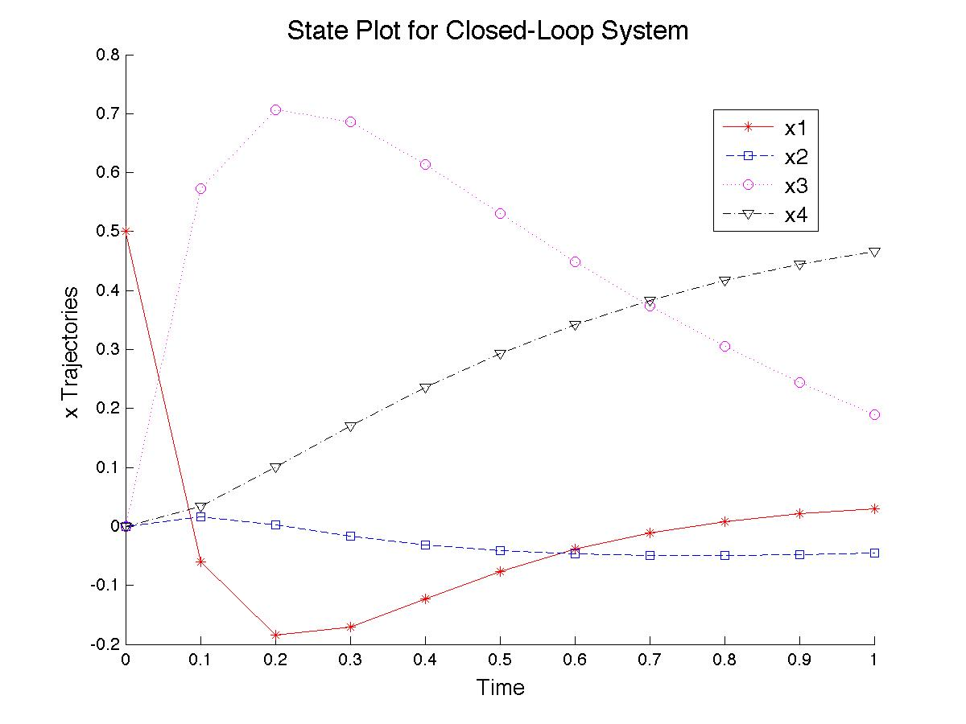

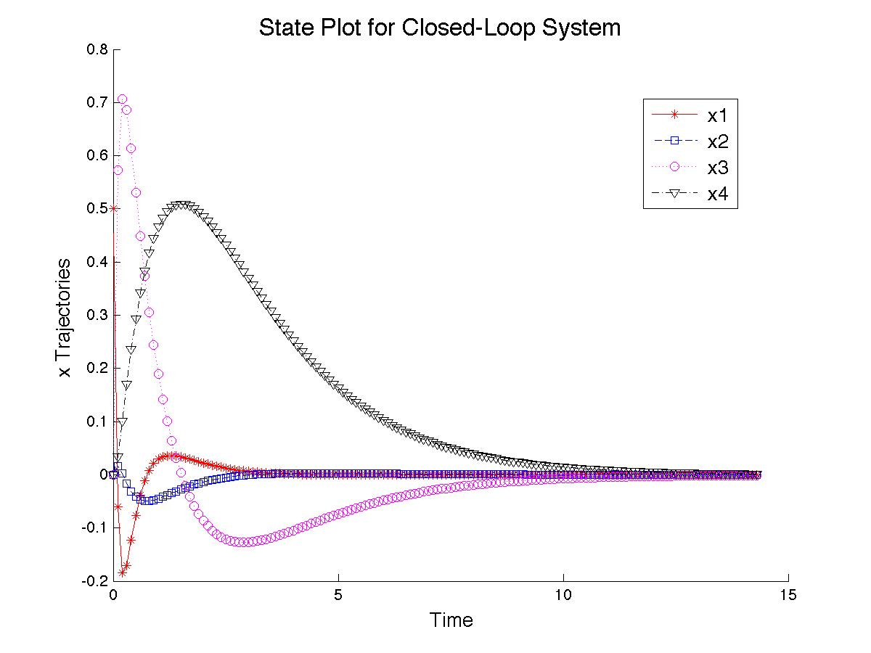

From the plots of the states for the closed-loop system, it is clear that the system is stable in that the state values go to zero. The behavior displayed by the closed-loop system completely differs from that of the other two systems, even at “small” times.